W300A-How to setup the P2P bridge mode?

Product line: Wireless Question category: Function configuration

Q: Why do we want to configure W300A to work as P2P bridge mode?
A: P2P bridge mode can connect with two wired network via wireless access points, which communicate by wireless signals and not by cables. This mode can free from the cable trouble.

The Connection Topology is as below:

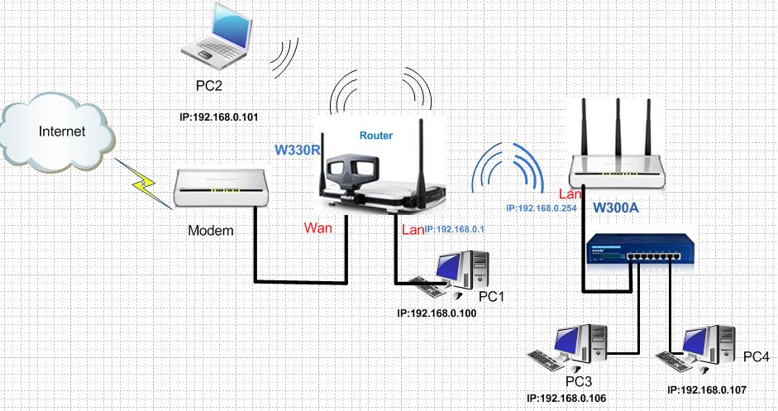
We have to do two parts of configurations.
1. The settings on your wireless router
Note:
Before we install the uplink router, we should make sure that the Access point worked as AP mode.
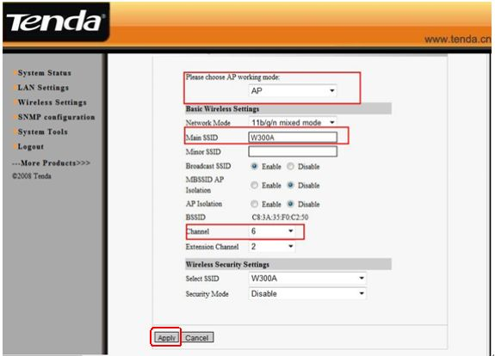
(1)Connect your computer to the LAN port of W330R with an Ethernet cable. Then login to the home page of W330R through type http://192.168.0.1 in the address bar, and a pop-up will appear and require you input username and password, both of them default are admin.
(2)After successfully login, please click WLAN settings→Basic settings to change the SSID to TendaW330R, and choose channel 6. Then click Apply to save the setting.
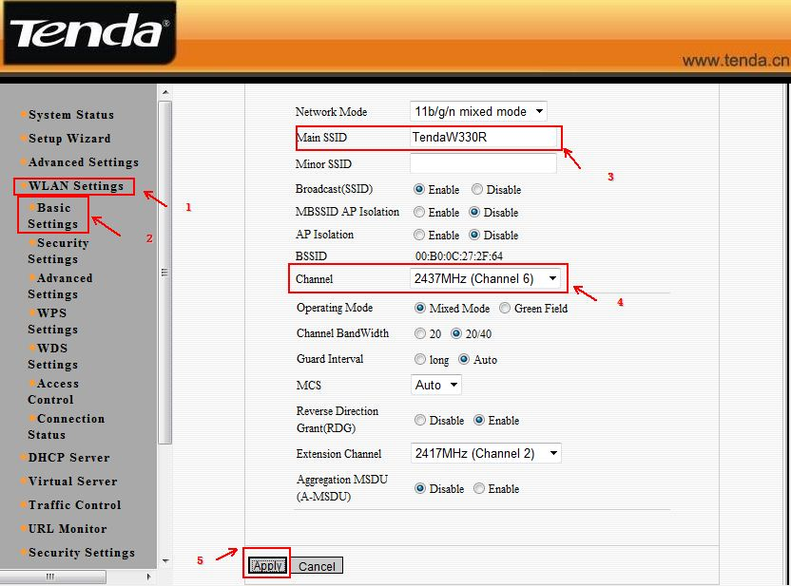
(4) Then click WLAN Settings→ Security Settings to choose WPA-personal as security mode and select AES as WPA Algorithms, please type your password in the blank of Pass Phrase.
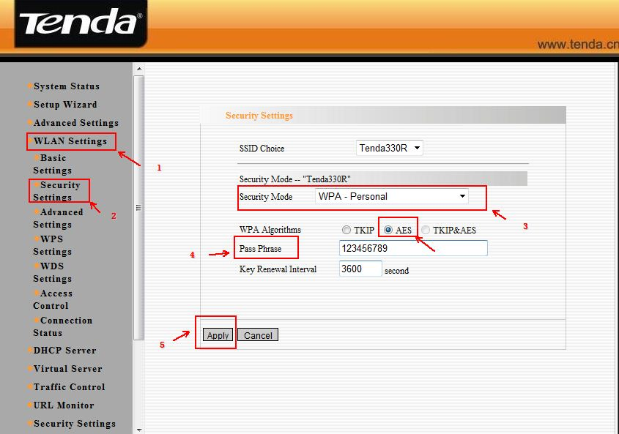
(5)Then click WLAN settings → WPS settings. And choose disable to disable WPS, and clicks save.
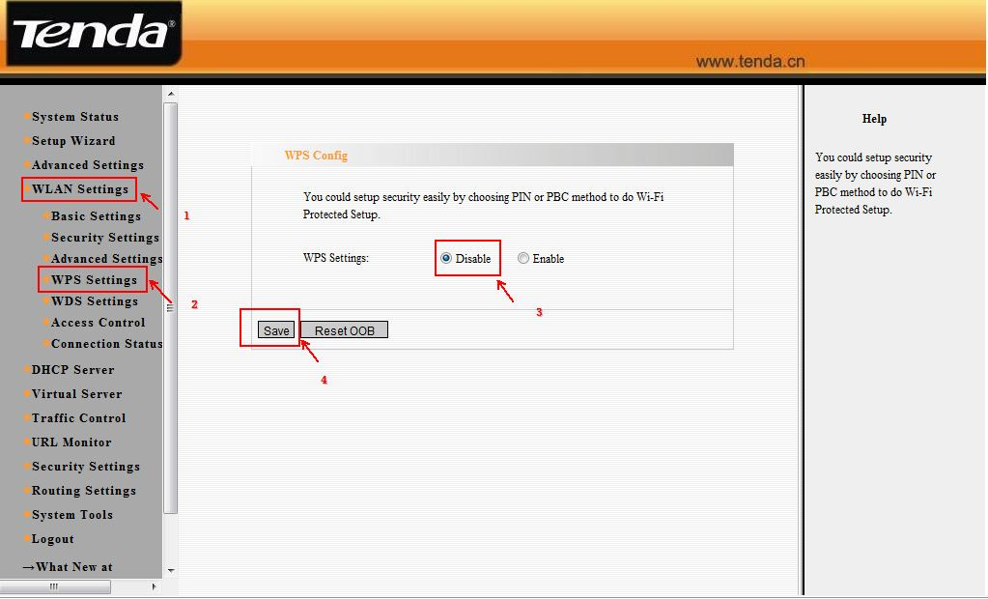
(5)Then click WLAN settings →WDS settings. Please choose Repeater Mode and the encrypt type choose NONE, then click on open scan and choose the AP’s signal. And click on apply to save it. Then the router will reboot. 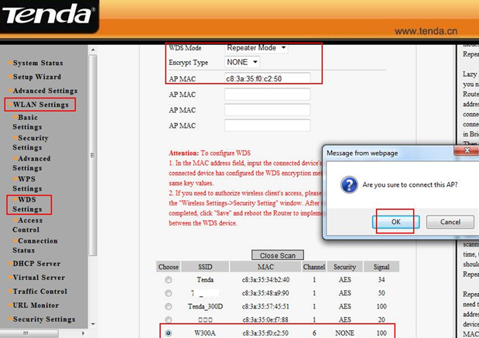
2. The settings on the W300A
The steps are as below:
(1).Login to the homepage of W300A
(2). After login, please click next 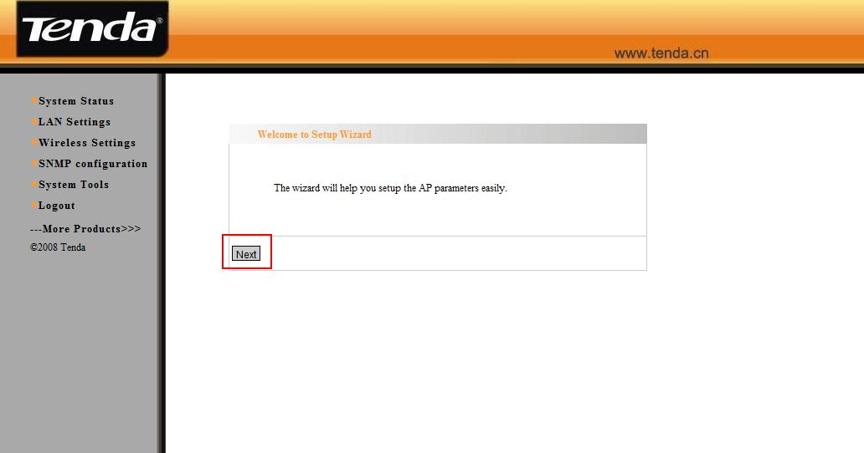
3. Select P2P Bridge Mode as working Mode. You should make sure that the channel and the WDS Encrypt Type should be the same as the uplink router. Then click on Open Scan; you will find your route’s signal. Please choose it and click on OK. Then click Apply and the W300A will reboot.
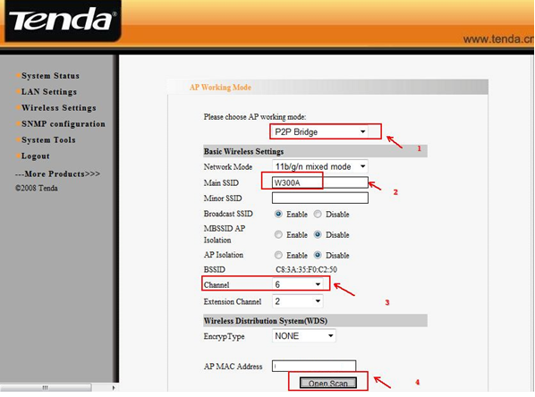
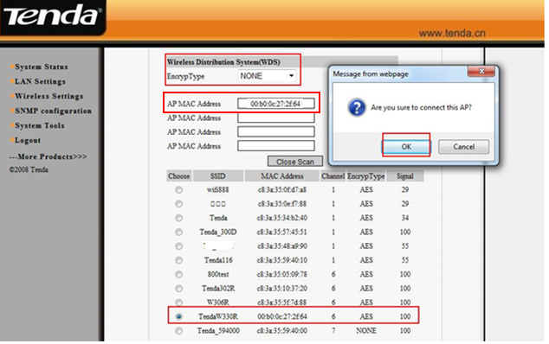
4. After it reboots successfully, please click on Wireless Setting→WPS Settings to disable it, and then click on save.
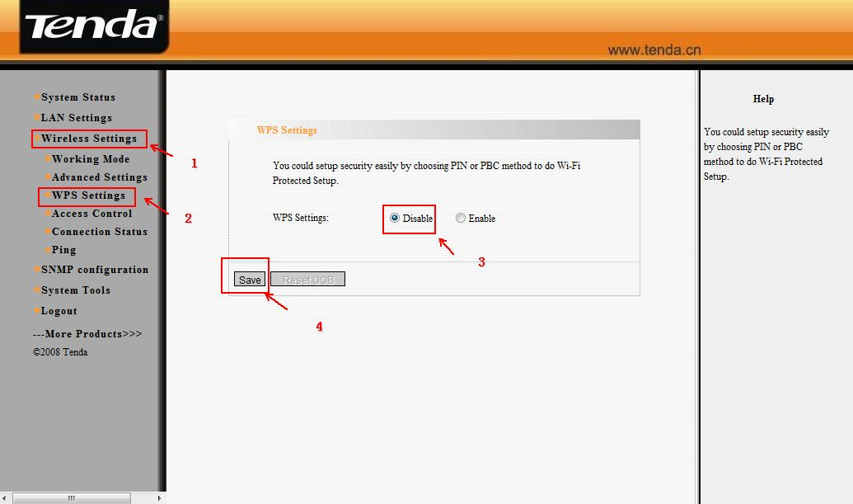
5. After we finished the configurations then the client that connects to the W300A with an Ethernet cable can get the ip address from the uplink router (e.g. as the topology above).
Note:
1. P2P bridge mode can only work with one wireless router/AP.
2. When the AP works at p2p mode, the other devices can only add the BSSID of the access points manually.

